PARAMETER –FILTER AND WHERE-OBJECT COMMANDLET

DIFFERENCE BETWEEN THE -FILTER PARAMETER AND THE COMMAND WHERE-OBJECT???

It should be noted that in most cases, when a Commandlet does have support for a -Filter or similar parameter it generally is significantly faster than using Where-Object.
In addition to the -filter parameter it is only used by some commandlets.
FOR EXAMPLE:
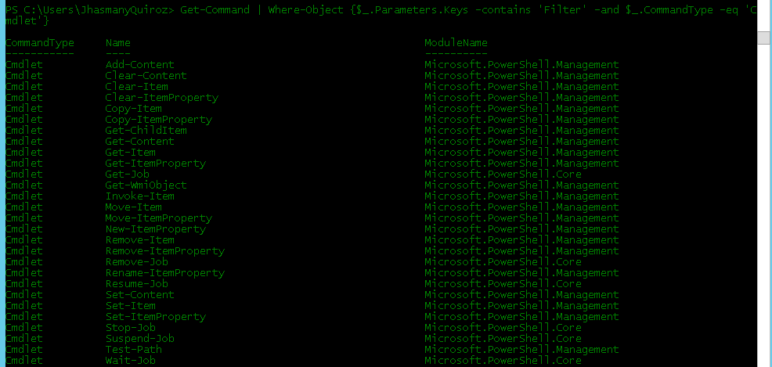

COMPARISON ON EFFICIENCY
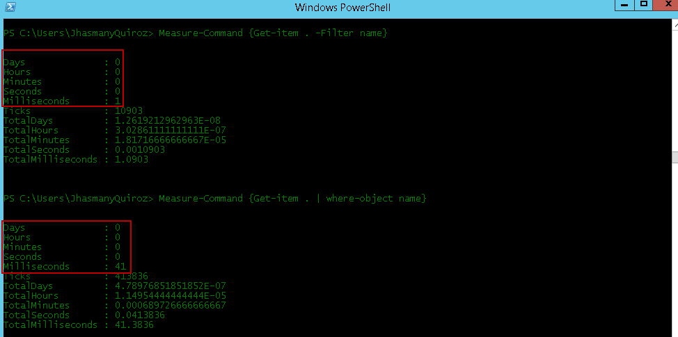

Another difference is that when you work with Microsoft Exchange, using the -filter parameter, this runs
On the server side while the commandlet where-object runs on the server side.
REFERENCES:
http://powershell.com/cs/forums/t/12229.aspx

That is CLR and DLR?

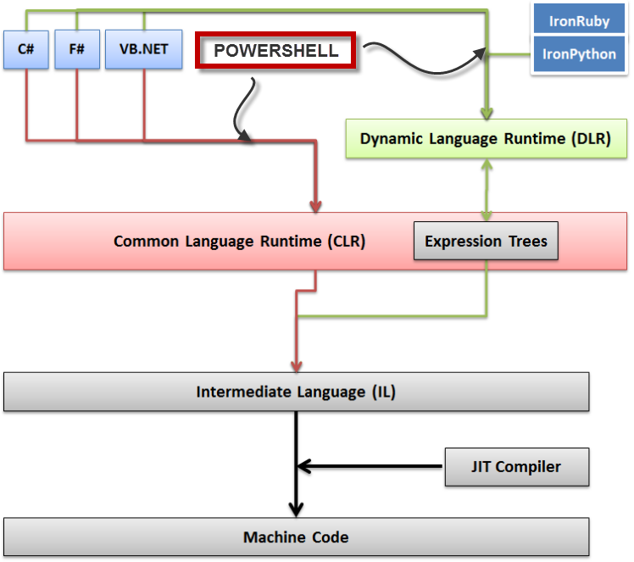
Understanding some of PowerShell's guts requires a pretty deep dive into the .NET Framework upon which the shell is built.
In PowerShell v1 and v2, the shell was built upon the Common Language Runtime, or CLR, just like every other .NET application. The CLR is vaguely like Oracle's Java Virtual Machine: It's the runtime in which all .NET code runs. When you code in C#, your code is "compiled" into Microsoft Intermediate Language (MSIL), and then the CLR compiles it into actual binary at runtime (called Just-in-Time, or JIT, compiling). The compiled binary image is cached for future use. That was actually the cause of a performance hit in v1, wherein the binary images weren't precompiled; the fix was to run the Ngen utility to generate those "native," or binary, images. For v2, Microsoft actually distributed pre-compiled binaries to keep performance swifter at startup.
So, back to PowerShell. A bunch of coders in Redmond wrote C# code in Visual Studio, hit "compile," and PowerShell came out the other end. Easy-peasy. When you ran your scripts, PowerShell interpreted them, parsing each bit of text one at a time and executing the appropriate tasks. Cmdlets are also written in .NET, and represent a "class" that PowerShell could call in order to make the cmdlets do its thang.
PowerShell v3, however, is different.
Microsoft has created a Dynamic Language Runtime, or DLR, that sits atop the CLR. The DLR is used to implement dynamic languages like Python and Ruby in .NET... and now it's used for PowerShell, too.
Who cares? It's mainly a performance thing, from our perspective, although Microsoft gets some development benefits, and developers who are hosting PowerShell get some advantages, too. For us, there's a big execution performance benefit, because functions and scripts aren't interpreted each time they're run, but are now compiled and executed, resulting in faster execution. In some cases, the compiled result is cached, speeding up future execution, too, since the compilation "hit" is bypassed. So the first time you run a script it might be a wee bit slower than under v2, but future runs should be much faster. This applies to scripts and to functions contained within scripts (and modules); any ad-hoc stuff you type directly into the console doesn't benefit. So there's now a big performance gain in modularizing your functions into scripts.
More fun for v3!

